**PORTFOLIO MANAGEMENT**

Table of Contents

Reading 39: Portfolio Management: An Overview 4

a. Describe the portfolio approach to investing 4

b. Describe types of investors and distinctive characteristics and need of each 4

c. Describe defined contribution and defined pension plans 4

d. Describe the steps in the portfolio management process 5

e. Describe mutual funds and compare them with other pooled investment products 5

Reading 40: Risk Management: An Introduction 8

a. Define risk management 8

b. Describe features of a risk management framework 8

c. Define risk governance and describe elements of effective risk governance 8

d. Explain how risk tolerance affects risk management 8

e. Describe risk budgeting and its role in risk governance 9

f. Identify financial and non-financial sources of risk and describe how they may interact 9

g. Describe methods for measuring and modifying risk exposures and factors to consider in choosing among the methods 9

Reading 41: Portfolio Risk and Return: Part I 12

a. Calculate and interpret major return measures and describe their appropriate uses 12

b. Describe characteristic of the major asset classes that investor consider in forming portfolios 13

c. Calculate and interpret the mean, variance and covariance of asset returns based on historical data 13

d. Explain risk aversion and its implications for portfolio selection 14

e. Calculate and interpret portfolio standard deviation 14

f. Describe the effect on a portfolio’s risk of investing in assets that are less than perfectly correlated 14

g. Describe and interpret the minimum-variance and efficient frontiers of risky assets and the global minimum-variance portfolio 15

h. Explain the selection of an optimal portfolio, given an investor’s utility (or risk aversion) and the capital allocation line 16

Reading 42: Portfolio Risk and Return: Part II 19

a. Describe the implication of combining a risk-free asset with a portfolio of risky assets 19

b. Explain the capital allocation line (CAL) and the capital market line (CML) 19

c. Explain systematic and nonsystematic risk, including why an investor should not expect to receive additional return for bearing nonsystematic risk 20

d. Explain return generating models (including the market model) and their uses 21

e. Calculate and interpret beta 22

f. Explain the capital asset pricing model (CAPM), including its assumptions and the security market line (SML) 23

g. Calculate and interpret the expected return of an asset using the CAPM 25

h. Describe and demonstrate applications of the CAPM and the SML 25

i. Calculate and interpret Sharpe ratio, Treynor ratio, M2 and Jensen’s alpha 25

Reading 43: Basics of Portfolio Planning and Construction 27

a. Describe the reasons for a written investment policy statement (IPS) 27

b. Describe the major components of an IPS 27

c. Describe risk and return objectives and how they may be developed for a client 27

d. Distinguish between willingness and the ability (capacity) to take risk in analyzing an investor’s financial risk tolerance 27

e. Describe the investment constraints of liquidity, time horizon, tax concerns, legal and regulatory factors and unique circumstances and their implications for the choice of portfolio assets 28

f. Explain the specification of asset classes in relation to asset allocation 28

g. Describe the principles of portfolio construction and the role of asset allocation in relation to the IPS 28

# Reading 39: Portfolio Management: An Overview

## Describe the portfolio approach to investing

Portfolio perspective refers to evaluate each investment in terms of their contribution to the risk and return of a portfolio.

Diversification ration: ratio of the risk of an equally weighted portfolio of n securities to the risk of a single random security from the n securities (or the average).

## Describe types of investors and distinctive characteristics and need of each

Individual investors.

Endowment: fund dedicated to providing financial support for a specific purpose.

Foundation: Fun established for charitable purposes or to fund research.

Banks: high return low risk loans and low cost deposits. Enough liquidity for their clients’ withdrawals

Insurance companies: pooled funds of many investors.

Mutual funds: “normal” funds, managing funds in a particular style.

Sovereign wealth funds: pools of assets owned by a government.

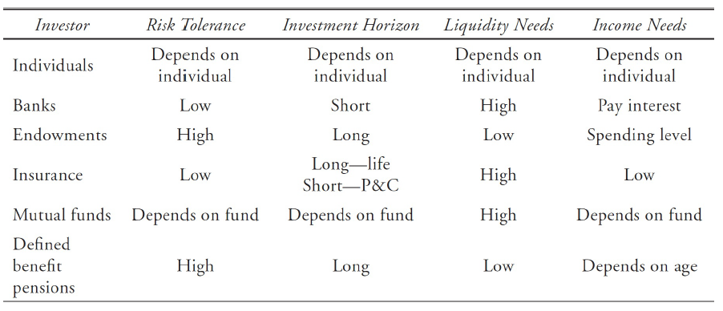

## Describe defined contribution and defined pension plans

Defined contribution pension plan: plan where the firm contributes to the employee’s retirement account. The investment decisions are left to the employee, who assumes the risk.

Defined benefit pension plan: the firm promises to make periodic payments to employees after retirement. Here the employer is the one who assumes the risk.

## Describe the steps in the portfolio management process

Major steps:

* Planning: analysis of investor’s risk tolerance, return objectives, time horizon, tax exposure, liquidity needs, income needs and any other unique circumstance. This analysis should result in an investment policy statement (IPS), disclosing the mentioned details. It should also include the benchmark that will be used and must be updated every few years or whenever a significant change in any of the mentioned constraints happen.
* Execution: Determine how funds will be allocated, where a top down analysis in which the current economic condition is examined and based on this, assets are picked. Once the assets classes are picked, the most attractive securities should be picked. For this phase, a bottom-up analysis is a good option (check if assets are undervalued).
* Feedback: monitor any change in the portfolio and rebalance it periodically. Measure performance relative to the benchmark.

## Describe mutual funds and compare them with other pooled investment products

**Mutual funds**: each investor owns shares that represent a portion of the overall portfolio.

The total net value of assets in the pool divided by the number of shares is known as net asset value (NAV).

In an open-end fund, investors can buy and redeem back to the fund (sell) shares at the NAV. Normally, operations are made at its past closing price.

Closed-end funds are the ones that do not take new investors and where shares cannot be redeemed. Shares trade like equity shares (on exchanges or OTC).

No-load funds do not charge additional fees for purchasing or redeeming shares (how do they make money), while load funds do.

**Types of mutual funds:**

Money market funds: invest in short-term debt securities.

Bond mutual funds: invest in fixed-income securities. What is the difference with money market? I believe that it is the term.

Stock mutual funds:

Index funds: passively managed and matches the performance of a particular index.

Actively managed funds.

**Other forms of pooled investments:**

Exchange-traded funds (ETF’s): similar to the closed-end funds as purchases and sales are made in the market. The important difference is that ETF’s are usually passively managed and that share prices, unlike the ones of closed-end funds, are forced to be kept close to their NAVs using special redemption provisions. This type of fund can be sold short, purchased on margin and traded at intraday prices. Commissions here are paid to brokerage firms and there is a bid and ask spread and dividends are usually paid out, not reinvested as in open-end funds.

No entendí las útlimas dos frases del párrafo (pag 156)

Check differences between dealers, brokers, market makers…

Separately managed account: owned and managed according to a single investor.

Hedge funds: are not so regulated as mutual funds. They are often only sold to qualified investors and minimum investment are quite high (between 250 K and 1 M). Hedge funds are classified by their strategy:

* Long/short funds: buy securities that are expected to outperform and sell the ones that are expected to underperform.
* Equity market-neutral funds: have long and short position that neutralize the fund with respect to the overall market movements. As long the long part outperforms the short movements, it may be profitable.
* Funds with bias: funds which are dedicated to a preferred position being either long bias or short bias.
* Event-driven funds: Invest in response to one-time corporate events.
* Fixed-income arbitrage funds: take long/short positions in debt securities while attempting to profit from minor mispricings.
* Convertible bond arbitrage funds: take long/short positions in convertible bonds and the equity shares of the same company in order to profit from relative mispricing between the two.
* Global macro funds: speculate on changes in international interest and currency exchange rates. The normally use derivatives and a great amount of leverage.

Buyout funds (private equity funds): typically buy entire companies and make it private. Theses processes normally involve acquiring a lot of debt (the purchased company) used to reorganize the company and increase its value. Then the firm or its parts its sold.

Venture capital funds: typically invest in companies which are in their start-up phase, with the intent of selling them later.

# Reading 40: Risk Management: An Introduction

## Define risk management

Risk management intends to identify risk tolerance of an organization, identify and measure the risks that the company faces and modify and monitor these risks. This process does not looks to minimize or eliminate these risks. So risk management tries to establish risk bundles and make certain choices and strategies that allow the company to keep its risk between its established bundles.

It is stated that first the risk bundle is selected and, depending of the level of risk, utility is maximized.

## Describe features of a risk management framework

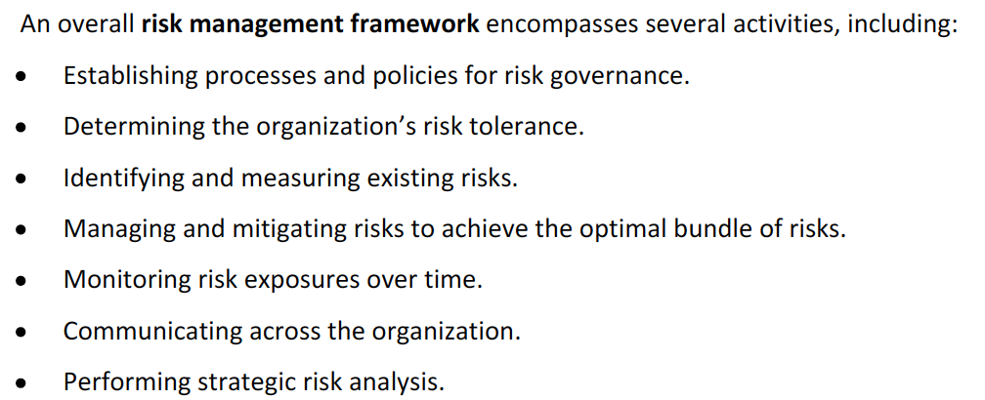

## Define risk governance and describe elements of effective risk governance

Risk governances refers to senior’s management determination of the risk tolerance of the organization, its strategy and the framework for oversight of the risk management function. All of this is done supporting the main goals of the organization.

A risk management committee can be stablished to lead the risk management of the company.

## Explain how risk tolerance affects risk management

Some of the factors that must be taken into account when evaluating risk tolerance are its expertise in the lines of business, its skill at responding to negative events, its regulatory environment and its financial strength. Inner and external risks should be examined, and it should be determined the expected benefits of bearing those risks.

## Describe risk budgeting and its role in risk governance

Risk budgeting refers to allocating resources to assets by considering their risk characteristics. The goal is to allocate resources to reach an overall accepted risk and maximize the returns. The way in which resources are allocated depends of the firm.

## Identify financial and non-financial sources of risk and describe how they may interact

Financial risks:

* Credit risk: uncertainty due to the risk that the counterparty does not fulfill its obligations.
* Liquidity risk: risk of loss when selling an asset less than its fair value due to current market conditions.
* Market risk: uncertainty related to market prices and interest rates fluctuation.

Non-financial risks:

* Operational risk: related to human error or faulty organizational process.
* Solvency risk: risk of being unable to operate because it ran out of cash.
* Regulatory risk: risk that comes from a change in the regulatory environment, imposing new costs to the firm.
* Governmental or political risk (including tax risk): includes the risks of political actions.
* Legal risk: exposure to uncertain future legal actions in detriment of the company.
* Model risk: risk that asset valuation risks are incorrect.
* Tail risk: risk of extreme events.
* Accounting risk: risk that the firm’s accounting policies or estimates are not correct.

Specific for individuals:

* Mortality risk.
* Longevity risk.
* Risk of health care expenses.

Interactions among risk should be taken into account.

## Describe methods for measuring and modifying risk exposures and factors to consider in choosing among the methods

Measures of risks:

* Standard deviation: may not be appropriate for non-normal probability distributions, specially where the distribution is negative skew or with positive excess kurtosis.
* Beta: This measure considers the risk-reduction benefits of diversification.
* Duration: measure of price sensitivity of debt security to changes in interest rates.

Derivative risks (Greeks):

* Delta: sensitivity towards the price of the underlying asset.
* Gamma: sensitivity of the delta to changes in the price of the underlying asset.
* Vega: sensitivity to the volatility of the price of the underlying asset.
* Rho: sensitivity towards the changes in the risk-free rate.

Tail risk (extreme values, also known as downside risk)) is usually measured with VaR and conditional VaR:

VaR: minimum loss over a period that will occur considering a specific probability.

CVaR: is the expected loss given that the loss exceeds a minimum amount.

**Subjective and market-based estimates of risk**

Stress testing: examines the effects of specific changes in a key variable.

Scenario analysis: is a what-if analysis that incorporates changes in multiple inputs.

Some risks that a company has not experienced will likely need subjective inputs. For operational risks of events that the company has not yet experienced, the company may need to generate certain assumptions. Another option could be to calculate an average of the losses of comparable firms that have experienced the event.

A subjective approach is sometimes needed and will always be better than not addressing the risk at all.

**Modifying risk exposure**

Every risk cannot be eliminated. Some must be reduced, other increased and only some eliminated.

One way to avoid risks is not engaging into an activity at all.

Diversification can be seen as an efficient way of bearing risks.

Self-insurance: refers to the decision of assuming the risk and being conscious that a loss can be created (sometimes, a reserve is kept).

Risk transfer (or shifting): another party takes the risk, for example, insurance. (*insurance companies can buy reinsurance from another company*). Derivatives is another way to shift risks.

Surety bond: is an insurance through which the insurance company will pay to its client if a third party fails to meet certain obligations (a supplier that does not deliver, for instance).

Fidelity bonds: Respond in the case of an employment misconduct or theft.

When an insurance is payed is because its cost is lower than the one of bearing the risk. SO when choosing how a risk may be reduced, the company should check both costs and benefits of every alternative.

# Reading 41: Portfolio Risk and Return: Part I

## Calculate and interpret major return measures and describe their appropriate uses

HPR:

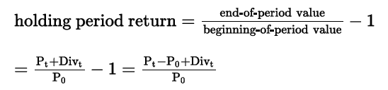

Arithmetic mean return: simple average of periodic return, is an unbiased estimator of the true mean of the underlying distribution of returns.



Geometric mean return: is a compound annual rate, when periodic rates vary from period to period, it is less than the arithmetic mean.

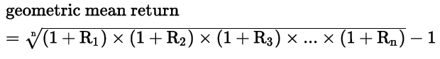

= (1+HPR) ^ (1/n) - 1

Money-weighted rate of return: is the IRR of a portfolio based on its cash flows. Inflows: beginning value, deposits. Outflows: withdrawals, interest, dividends, ending values. When no changes happen, the period’s cash flows must be zero. The IRR must be calculated using the shortest interval of time between cash flows and then translate it to an effective annual rate.

Gross return: total return in a portfolio before deducting fees.

Net return: total return after deducting fees. *Costs necessary to generate investment returns are deducted in both gross and net return.

After-tax nominal return: return after tax liability is deducted.

Real return: nominal return adjusted for inflation.

Leveraged return: return to an investor that is a multiple of the return on the underlying asset. Is calculated as the percentage that the gain represents from the initial cash investment. Is leveraged because the investor only pays for a lower amount than the price of the underlying asset.

## Describe characteristic of the major asset classes that investor consider in forming portfolios

Normally distributions are not normal, they are negatively skewed with greater kurtosis. Liquidity, risk and returns are the major characteristics to consider.

## Calculate and interpret the mean, variance and covariance of asset returns based on historical data

**Variance**

Population:

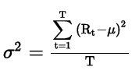

Sample:

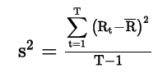

**Covariance and correlation**

Measures the extent to which two variables move together over time. If zero, there is no linear relation between the variables.

Sample covariance:

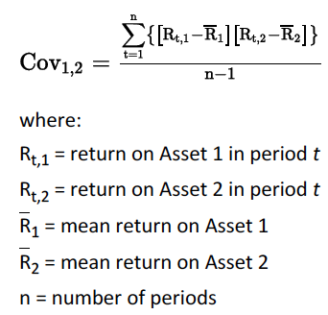

To standardize and find the correlation

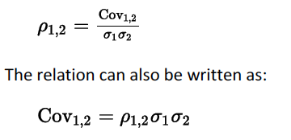

## Explain risk aversion and its implications for portfolio selection

Risk-averse: investor that dislikes risk.

Risk-seeking (loving): prefers more risk, given equal expected returns, it will look for the riskier investment.

Risk-neutral: Has no preference regarding risk and will be indifferent when choosing between two investment with equal expected return and different risk.

*Return might, however, be enough to pursue riskier portfolios.

## Calculate and interpret portfolio standard deviation

A portfolio of two assets has a variance that can be computed as following:



Then, the standard deviation will be:

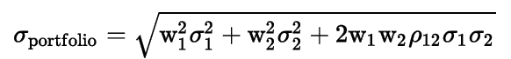

*How to calculate the standard deviation of more than two assets.

## Describe the effect on a portfolio’s risk of investing in assets that are less than perfectly correlated

If the correlation of two risky assets equals one:

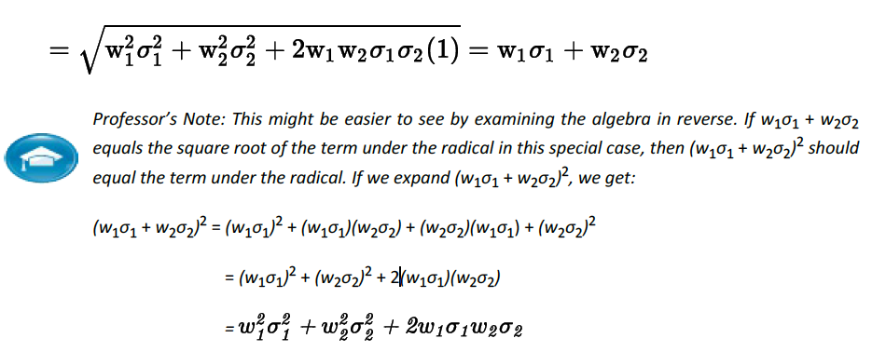

Here, the standard deviation is simply a weighted average. So, when the covariance is less (or zero or negative), the standard deviations falls.

Whenever the correlations decreases (diversification), the greater the risk reduction.

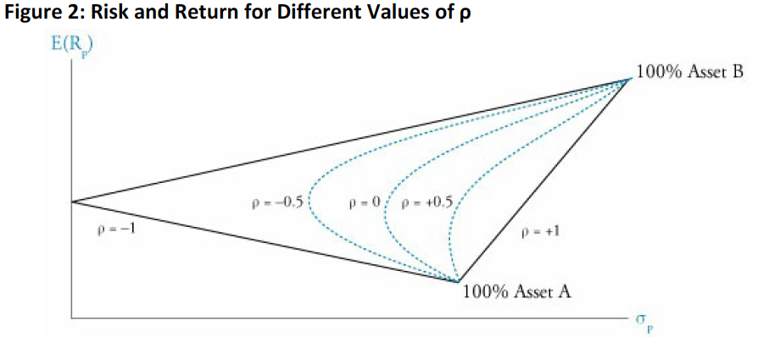

*Exactly what is being graphed??

## Describe and interpret the minimum-variance and efficient frontiers of risky assets and the global minimum-variance portfolio

For each level of return, the portfolio can have different combinations. The ones with lowest risk are the minimum-variance portfolios. All of the portfolio make up the minimum-variance frontier.

The efficient frontier is the portfolios with higher return per unit of risk (it is the top portion of the minimum-variance frontier). A risk-averse investor will choose portfolios found in the efficient frontier.

The portfolio with lower risk is the global minimum-variance portfolio.

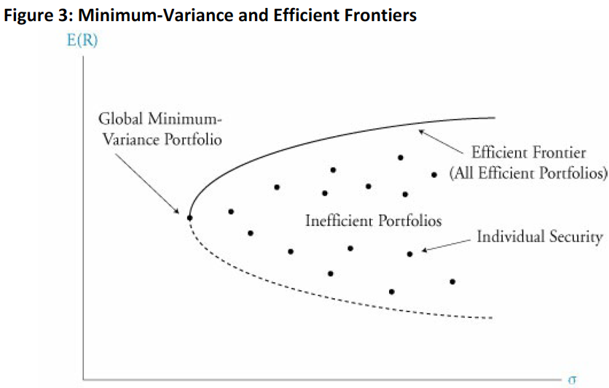

## Explain the selection of an optimal portfolio, given an investor’s utility (or risk aversion) and the capital allocation line

An investor’s utility function represents its preferences in terms of risk and return. The indifference curve represents these combinations. In the indifference curve, the utility is the same for all the points along the curve. In the figure, I1 will be the preferred curve.

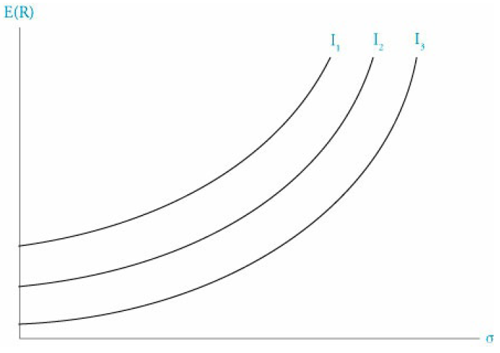

A more risk-averse investor will require a curve with a higher slope (risk aversion coefficient).

Whenever a risk-free asset is combined with a risky asset, the standard deviation is computed as:



Where A is the risky asset. The relationship between the combinations of risk-free and risky portfolio results in a linear function called the capital allocation line.

Two-fund separation theorem: assures that every investors’ optimal portfolios are composed by risky and risk-free assets.

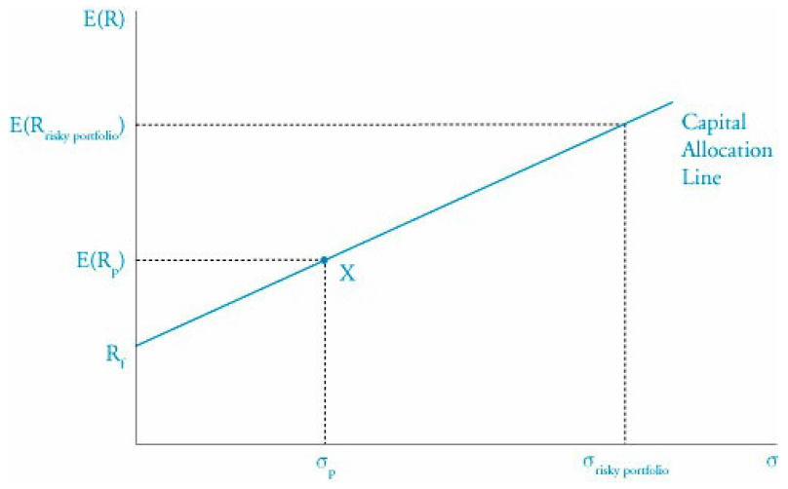

The capital allocation line may be combined with indifference curves:

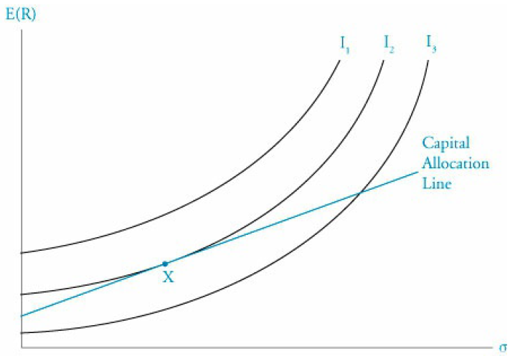

If an investor is less averse to risk, it will face an indifference curve steeper (IB).

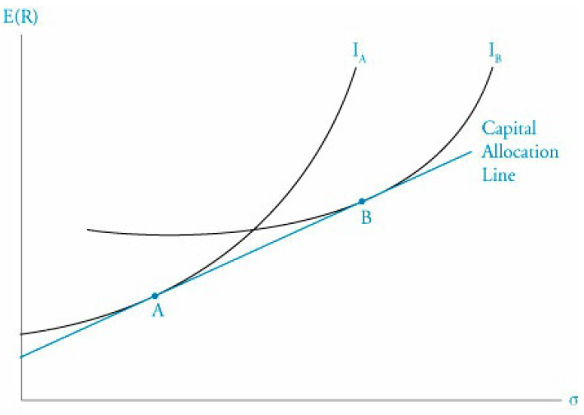

# Reading 42: Portfolio Risk and Return: Part II

## Describe the implication of combining a risk-free asset with a portfolio of risky assets

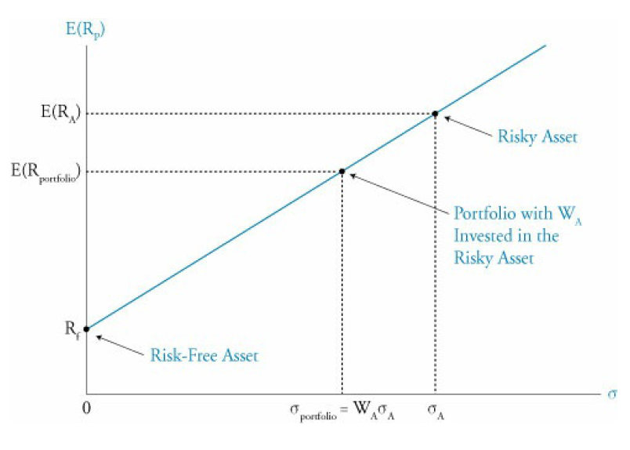

## Explain the capital allocation line (CAL) and the capital market line (CML)

Why is the CAL linear?

The most desirable CAL is the one that covers more desirable portfolios (A in the following figure):

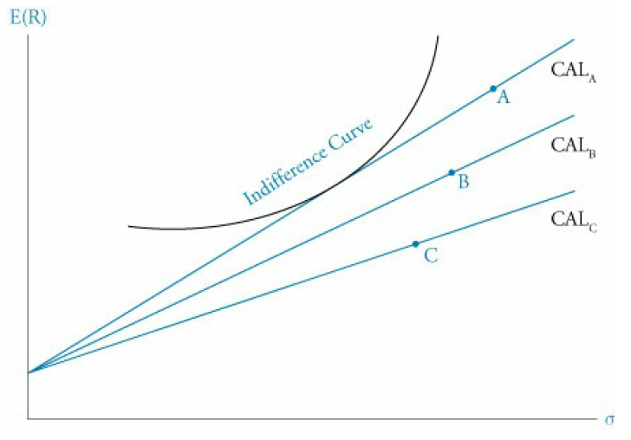

So it will be the one that is tangent with the indifference curve (preference of risk and return).

A general assumption is that every investor has similar risk and return preferences. Assuming this, the CAL becomes the CML.

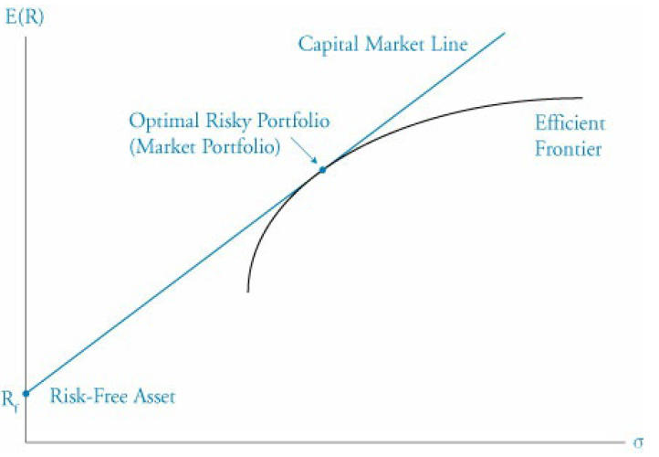

How to jump from indifference curve to the efficient frontier?

The market portfolio is like the main index of a market?

The function of the CML will go like this:

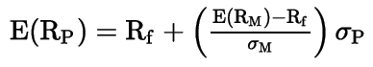



*Why is the slope calculated like that?

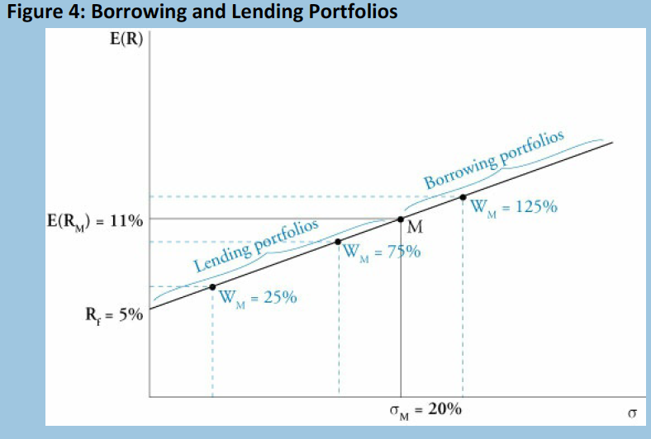

Below M are portfolios created by lending at the risk-free rate. Above M, the portfolios are created by borrowing.

## Explain systematic and nonsystematic risk, including why an investor should not expect to receive additional return for bearing nonsystematic risk

Unsystematic risk (unique, diversifiable or firm-specific risk).

Systematic risk (nondiversifiable or market risk). It is the response of the firms returns towards changes in the market factors.

The total risk is the sum of these two types of risk.

It is not necessary to invest in every single security to significantly reduce the unsystematic risk.

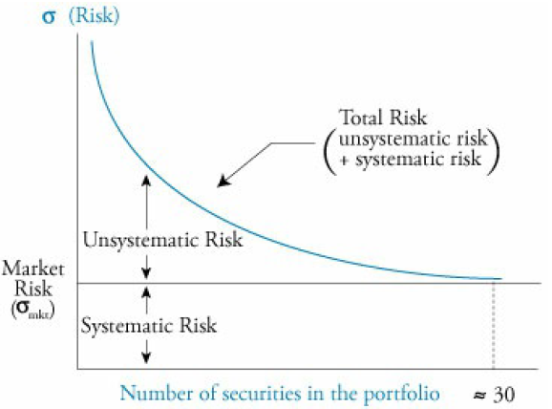

As diversification is “free” it is said that the market should not compensate for nonsystematic risk, hence the importance of the systematic risk. So, a stock which is highly sensible to market risk should, in theory, pay more than one in which the firm’s specific risk is the highest. This is all according to capital market theory.

## Explain return generating models (including the market model) and their uses

Return generating models: used to estimate expected returns on risky securities.

Multifactor models: use different macroeconomic factors to establish the expected return.

Types of factors that explain returns:

* Macroeconomic
* Fundamental
* Statistical (do not actually come from finance and often only work in certain cases)

General multifactorial model:



Factor sensitivity or loading: Betas.

Fama and French: uses firm size, book value to market value ratio and market premium (market portfolio – risk-free).

Carhart: adds a fourth factor which measures price momentum using prior period returns.

Single-index model (no es CAPM):



Market model:

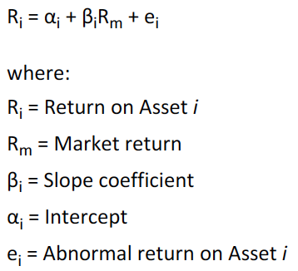

Esto qué:



## Calculate and interpret beta

The beta is a standardized measure of covariance between the asset and the market return.

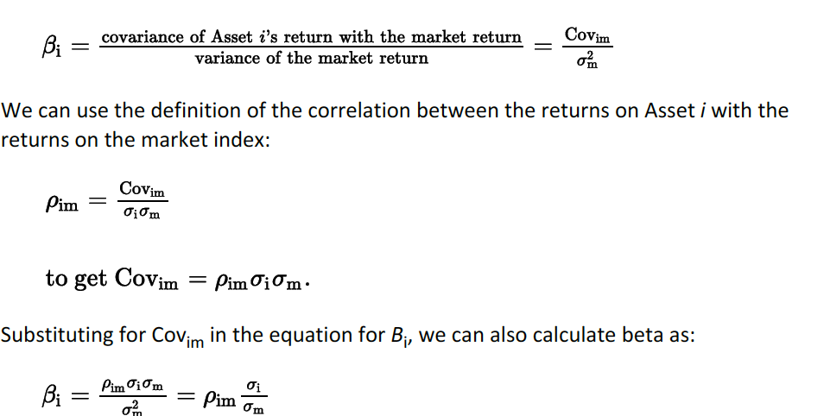

In practice, betas are calculated by regressing the returns on the asset on those of the market index.

Least squares regression line: minimizes the sum of the square distances of the points ploted.

Security characteristic line: is the regression line that regress the assets return on the market return. Its slope is the beta.

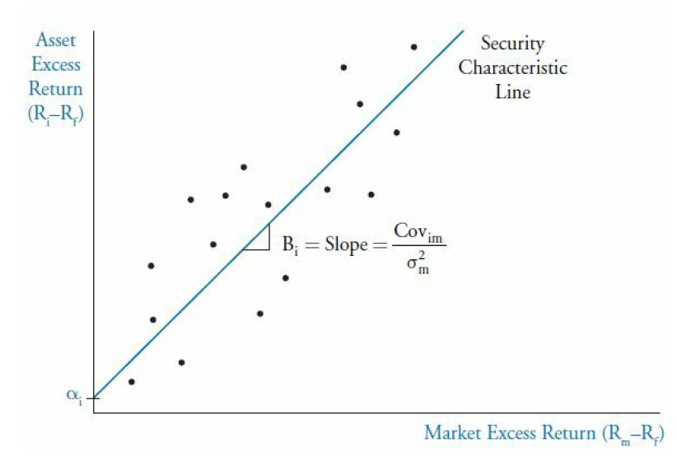

## Explain the capital asset pricing model (CAPM), including its assumptions and the security market line (SML)

Considering that the only priced risk is the systematic risk, the SML considers the covariance between the asset and the market as the measure of risk:

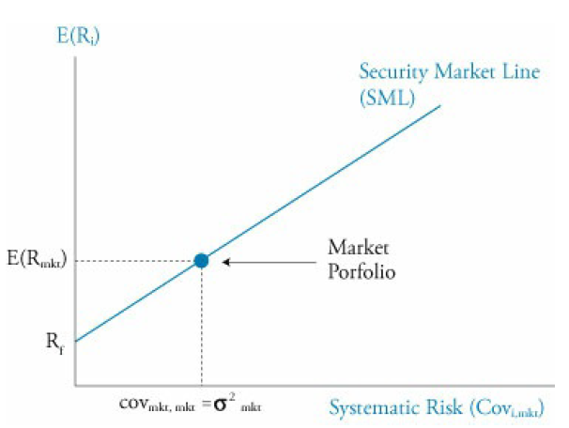

That is the market portfolio since in that point the beta = 1. The SML shows the equilibrium return based on the beta, where the expected return equals the required return (forecast = CAPM). If it does not, the security will be plotted out of the SML, as it will be under or overvalued.

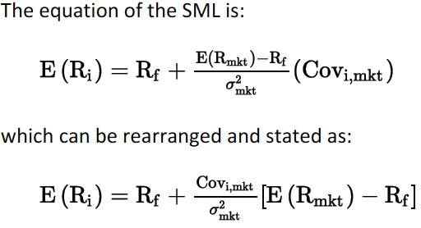

The slope is the formula for beta. The formula represents the CAPM.



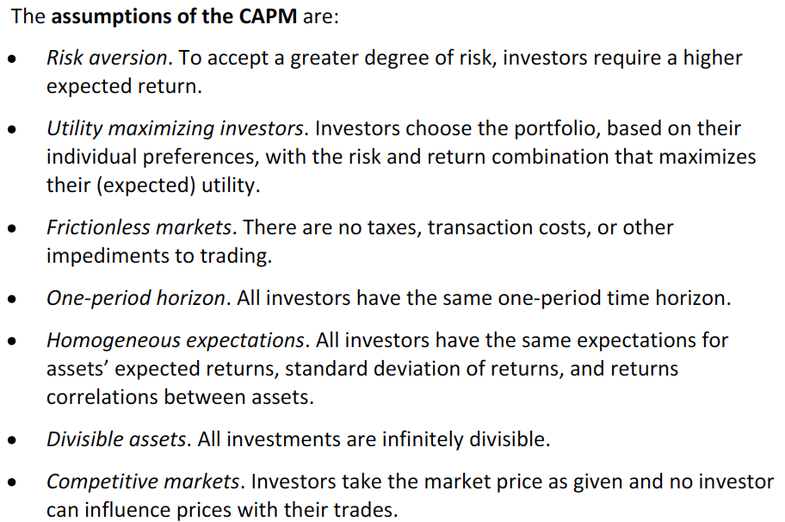

**Difference with the CML**

Equation of the CML:

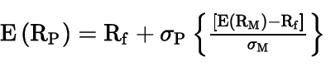

In the x-axis, the CML uses total risk and plots only efficient portfolios.

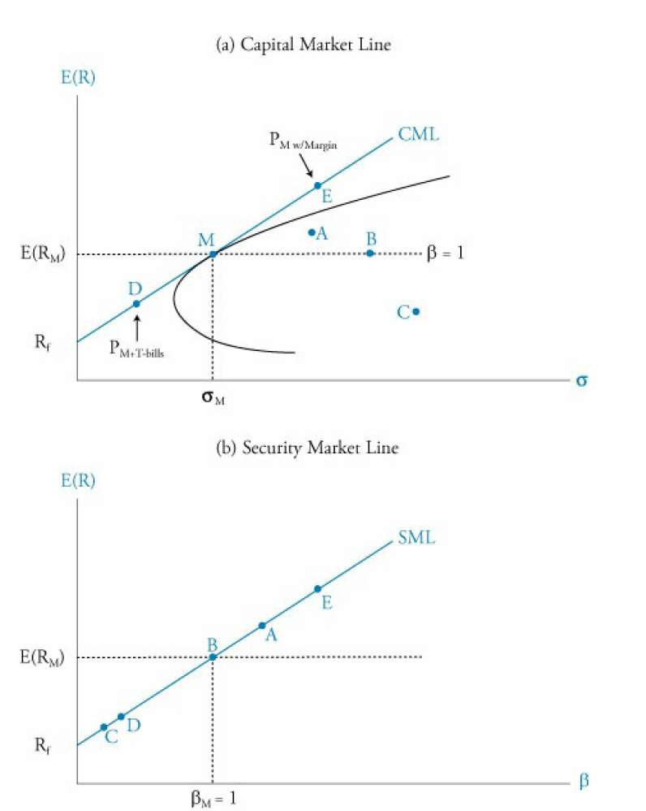

Portfolios that are not in the CML, are not efficient. Every security and portfolio is plotted in the SML.

## Calculate and interpret the expected return of an asset using the CAPM

Simple.

## Describe and demonstrate applications of the CAPM and the SML

If the expected return is plotted below the SML, it is overpriced (overvalued), so the expected return is too low give its systematic risk. Short sell will be the correct strategy.

If it is above the SML, it will be the other way around.

The CAPM can be used to calculate the required return. The expected return is calculated considering forecasts.

## Calculate and interpret Sharpe ratio, Treynor ratio, M2 and Jensen’s alpha

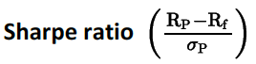

Shows the excess return per unit of total risk. All of the portfolios that fall in CML face the same Sharpe ratio. It is also used on the CAL, what’s the difference?

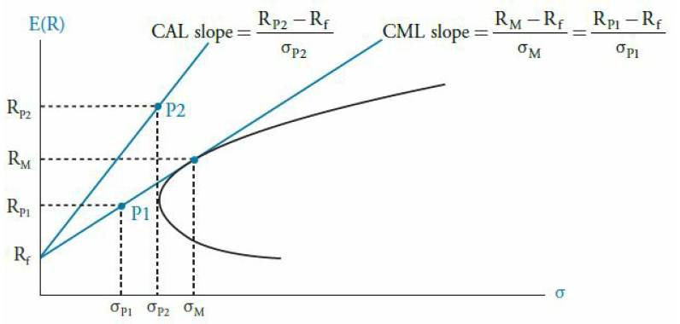

**M-squared**

Similar to the Sharpe ratio by stated in percentage terms:



The first term is the excess return of a leveraged portfolio p*.

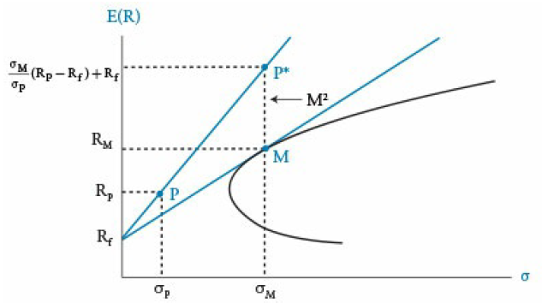

**Treynor measure:**

Is based on a slope like the Sharpe ratio. It only considers systematic risk.

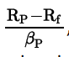

**Jensen’s alpha:**

Is a measure of percentage return in excess of those from a portfolio with the same beta that lies on the SML.



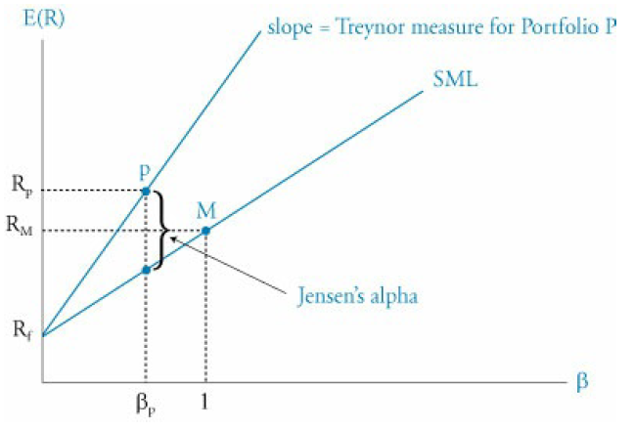

If a portfolio is well diversified, the correct measures to use are the Treynor measure and the Jensen’s alpha. If not, the other two measures should be used.

It is important that portfolios that lie above the CML or the SML tend to be more desirable.

# Reading 43: Basics of Portfolio Planning and Construction

## Describe the reasons for a written investment policy statement (IPS)

Begins with investor’s goals in terms of risk and return. The IPS is very important to produce a good result.

## Describe the major components of an IPS



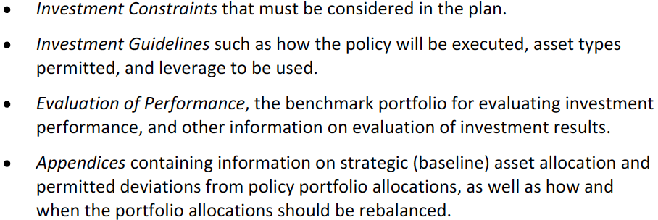

## Describe risk and return objectives and how they may be developed for a client

Type of objectives:

* Absolute.
* Relative.

These objectives must be compatible.

## Distinguish between willingness and the ability (capacity) to take risk in analyzing an investor’s financial risk tolerance

Ability to bear risk: depends on financial circumstances.

Willingness to bear risk: depends on attitudes and beliefs (subjective).

Whenever the willingness is hogh but the ability is low, the adviser’s assessment should give more relevance to the ability.

However, whenever the situation is the other way around, the adviser may educate the investor to clear any misconceptions but should not change the investor’s personality characteristics that influence its willingness.

## Describe the investment constraints of liquidity, time horizon, tax concerns, legal and regulatory factors and unique circumstances and their implications for the choice of portfolio assets

The important points to cover in an IPS are the ones stated in the LOS. R-R-T-T-L-L-U. (first is risk and the second return).

* Liquidity: how claimable are the funds. The lower, the riskier.
* Time horizon: the longer, the riskier.
* Tax situation: tax treatment of each type of investment.
* Legal and regulatory: specific to the investor.
* Unique circumstances: specific preferences or restrictions.

## Explain the specification of asset classes in relation to asset allocation

Strategic asset allocation: % allocated to each asset class. Per class, correlations should be high. Between classes, it should be low. This should be disclosed in the IPS.

## Describe the principles of portfolio construction and the role of asset allocation in relation to the IPS

Using computer programs, an asset manager may generate an efficient frontier and select, and asset allocation based on the IPS’s specific risk and return objectives (strategic allocation).

Tactical asset allocation: change weights to take advantage of short-term opportunities.

Security selections: deviations from index weights. Under and overweight.

Active management increases the risk of the portfolio.

Risk budgeting: sets risk limits to strategic allocations, tactical allocation and security selection.

Two issues to consider in active portfolio management:

* Having multiple managers managing to the same benchmark may neutralize the risk.
* Tax negative consequences.

Core-satellite approach: address the issues. Invests the majority in passive strategies and a minority in active strategies.